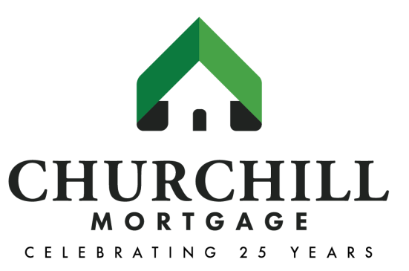

EXECUTIVE BIOGRAPHY

Lawson H. (Mike) Hardwick, III

Founder and President
Churchill Mortgage Corporation
www.ChurchillMortgage.com

Lawson H. (Mike) Hardwick, III is founder and president of Brentwood, Tenn.-based Churchill Mortgage Corporation, a leader in the mortgage industry providing conventional, FHA, VA and USDA residential mortgages across 46 states and the District of Columbia.

With more than 40 years of mortgage and banking experience, Hardwick is a highly successful mortgage lender and a seasoned businessman. With experience as a mortgage, insurance and real estate broker, the span of knowledge and expertise Hardwick possesses is invaluable. Focused on providing a top quality experience to borrowers, Hardwick has proven himself as a true entrepreneur building and maintaining multiple financial companies.

The first half of Hardwick’s career was spent in commercial and investment banking with two nationally known firms. In the early 80's, he founded a condo conversion company, which grew to be the third-largest in the nation. Shortly after the peak of that business, Hardwick became one of the principal founders of Franklin National Bank in Franklin, Tenn. He served as an executive vice president until 1992, and then founded Churchill Mortgage. He continued serving on the Board of Directors for Franklin National Bank for several years thereafter. The bank was later acquired by Fifth Third Bank.

Hardwick graduated from Gateway College in St. Louis, Mo. where he received a bachelor’s degree in Theology and Music. He received a BBA in Finance from Belmont University in Nashville, Tenn. where he was a member of the university’s baseball team. Hardwick has served on many boards and committees, including Friends of the Arts Board at Belmont University and the Finance & Endowment Committee for Christ Church Nashville. He is also a founder and board member of Real Estate Services of America, Escrow Services of Tennessee, Churchill Agency and Equity Express.

A life-long resident of Nashville, Hardwick resides there with his wife Stephanie and is a proud father of two daughters and two sons. In addition, his autobiography, “Keep Chopping Wood,” was published in August 2016.

Founded in 1992, Churchill Mortgage is a privately-owned company by its more than 400 employees. A full-service and financially sound leader in the mortgage industry, the company provides conventional, FHA, VA and USDA residential mortgages across 46 states. As heard on personal finance expert and author Dave Ramsey’s nationally syndicated radio show, the lender’s mission is to help borrowers achieve debt-free homeownership and build wealth through a smarter mortgage plan, regardless of their starting point. Churchill Mortgage is a wholly-owned subsidiary of Churchill Holdings, Inc.

Churchill Mortgage’s notable achievements include recognitions as a “Top Lender” by Scotsman Guide: Residential, a six-time “Top Workplace” by The Tennessean and a “Top 100 Private Company” and “Best in Business” by the Nashville Business Journal. For more information about Churchill Mortgage, visit www.churchillmortgage.com or follow the company on LinkedIn, Twitter @ChurchillMtg, Instagram and Facebook at www.facebook.com/churchillmortgage.

###

